Chip back potential is the level which bulk silicon is maintained by on-chip connection, or it is the level to which the chip back must be connected when specifically stated below. If no potential is given the chip back should be isolated.

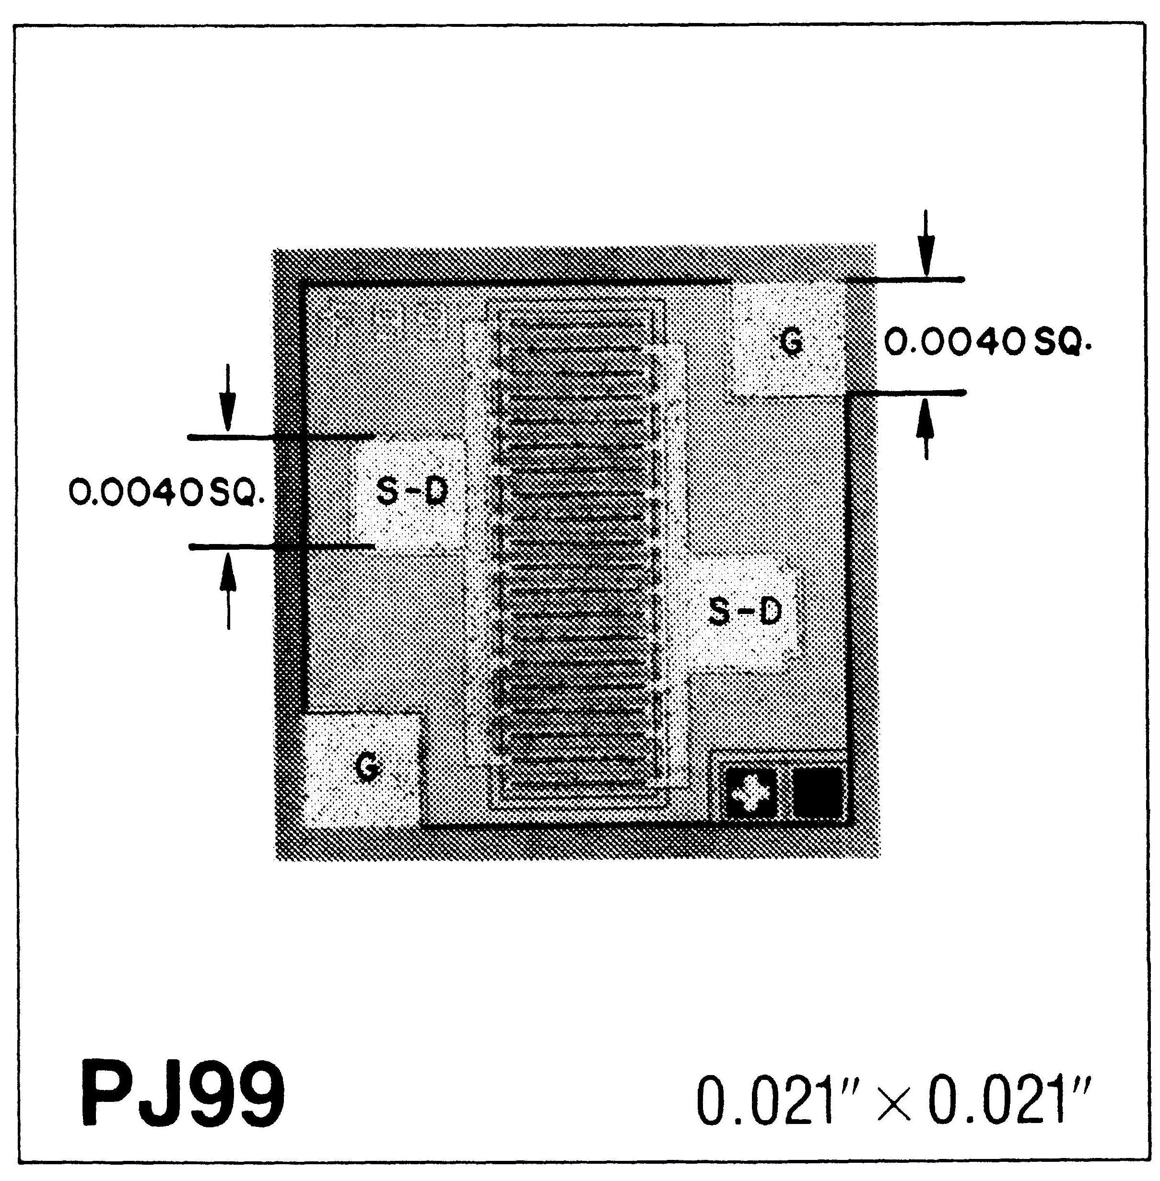

Top Material: Al
Backside Material: Si
Bond Pad Size: .004” X .004”
Backside Potential:
Mask Ref: PJ99

DG 10.1.2
APPROVED BY: DK DIE SIZE .021” X .021” DATE: 11/23/26
MFG: SPRAGUE/ALLEGRO THICKNESS .006” P/N: 2N5115

Rev B, 7/19/02

